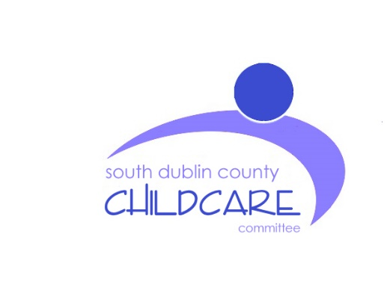
SOUTH DUBLIN CHILDCARE COMMITTEE
CHILD SAFEGUARDING STATEMENT

April 2018

Checklist

Developing a Child Safeguarding Statement | Complete
Carry out the Risk Assessment
List details of the service provided and management structure
List principles to protect children from harm
Appoint a Relevant Person
Draw up a list of Mandated Persons
Check you have all the required policies and procedures

Amend your child protection and welfare reporting procedures, to include:
- information on Mandated Persons and how they report
- information from Children First, National Guidance, 2017

Develop new procedures to:
- Appoint a relevant person
- Draw up list of Mandated Persons

Provide all staff and board members with information about their responsibilities under the Children First Act, 2015
Include details on review and implementation

South Dublin County Childcare Committee Child Safeguarding Statement
South Dublin County Childcare Committee’s strategic focus is to increase the provision of quality childcare facilities and services for children aged birth to 14 years, and to develop a co-ordinated approach to the delivery of childcare services in South Dublin.
South Dublin County Childcare Committee is a company limited by guarantee and a registered charity.

SDCCC’s COMMITMENT TO SAFEGUARD CHILDREN FROM HARM
- Our service believes that the welfare of children is paramount. We are committed to child-centred practice in all our work with early year’s services.
- We are committed to upholding the rights of every child and young person, including the rights to be kept safe and protected from harm, listened to, and heard.
- Our policy and procedures to safeguard children and young people reflect national policy and legislation and are underpinned by Children First: National Guidance for the Protection and Welfare of Children, DCYA, 2017, Child Safeguarding: A Guide for Policy, Practice and Procedure, Tusla, 2018, and the Children First Act 2015.
- Our policy declaration applies to all paid staff, volunteers, committee/ board members and students on work placement within our organisation. All committee board members, staff, volunteers and students must sign up to and abide by the policies, procedures and guidance encompassed by this policy declaration and our child safeguarding policy and accompanying procedures.
- SDCCC will review our child safeguarding statement and accompanying child safeguarding policies and procedures every 2 years or sooner if necessary, due to service issues or changes in legislation or national policy.
- Designated Liaison Person (DLP) for Child Protection
DLP: Rachel Kielthy  Position: manager  C6 Clondalkin Civic Offices  Ninth Lock Road, Clondalkin, Dublin 22  P: 4570122 / 0868325092 | Deputy: Orán Sweeney  Position: Programme Development Officer  C6 Clondalkin Civic Offices  Ninth Lock Road Clondalkin, Dublin 22  P: 4570122 / 087 1259839

- RISK ASSESSMENT

In accordance with the Children First Act 2015, SDCCC has carried out a risk assessment of any potential risk for SDCCC in relation to Child Protection and of any potential for harm to a child. A written assessment setting out the areas of risk identified and the service procedures for managing those risks is summarised below:

Risk Identified | Policies and/or Procedures in place to manage Risk
SDCCC staff Garda vetting | All new staff members are garda vetted when they start  and every 3 years after that.
Staff being left in rooms on their own with  children | Policy in place for sdccc staff during on-site support visits

- CHILD SAFEGUARDING POLICIES AND PROCEDURES

As required by the Children First Act 2015 and Children First National Guidance for Protection and Welfare of Children, 2017 the following safeguarding policies/procedures/measures are in place
- A Designated Liaison Person and Deputy have been appointed
- Child Protection and Welfare Reporting Procedures
- Confidentiality Policy
- Policy for Dealing with Allegations of Abuse or Neglect Against Employees
- Procedure for Managing Child Protection Records
- Recruitment Policy
- Garda Vetting Policy
- Induction Policy (which includes procedures to inform new staff about the Child Safeguarding Statement and accompanying safeguarding policies and procedures)
- All staff have completed the Tusla eLearning module – Introduction to Children First and relevant staff have attended Always Children First Child Protection Training.
- Staff have access to regular Supervision and Support in line with the service policy.
- Complaints Policy
- Social Media Management Policy

- IMPLEMENTATION AND REVIEW

- SDCCC recognise that implementation is an ongoing process. SDCCC is committed to the implementation of this Child Safeguarding Statement and the accompanying child safeguarding policies and procedures that support our intention to keep children safe from harm.

- This Statement will be reviewed every 2 years or as soon as practicable after there has been a material change in any matter to which the statement refers.

- This statement has been published on the service website and is displayed in the service. It has been provided to all board members, staff, volunteers and any other persons involved with the service. A copy of this Statement will be made available to Tusla if requested.

Signed: ____ Date: _________________
Larry O’Neill (Chairperson)

Signed: ____ Date: _________________
Rachel Kielthy (Manager)
For further information on this Statement, contact Rachel Kielthy p:4570122

RISK ASSESSMENT TEMPLATE
Person(s) carrying out Risk Assessment: Date:
Risk Identified | Who is Responsible? | What is Currently in Place to Manage the Risk | What Future Actions are Needed?
Garda vetting | Rachel |  | Staff need to have garda vetting updated every 3 years. Some were last done in 2011 so have since been re-applied for.  List need sto be kept on P:drive with staff names and dates of when re-application is required
SDCCC staff onsite support visits | Rachel |  | Policy in place for sdccc staff during on-site support visits. Ensure all staff are aware and adhere to the policy

